Application Form to the Research Ethics Committee of ETH Zurich

To be submitted to: ETH Zürich, Ethics Commission, Office of Research, HG E 32.2, 8092 Zurich

A. General Information

Project Title
Investigating the effects of affective game design on player motivation and task performance

Principle investigator
Name | Address of institute | E-Mail address | Phone number
Prof. Dr. Ing. Robert Riener | TAN E 4, Tannenstrasse 1 | riener@mavt.ethz.ch | 0446326679

Involved collaborators
Name | Address of institute | Email address | Phone number
Dr. Peter Wolf | TAN E 6.2, Tannenstrasse 1 | Peter.Wolf@mavt.ethz.ch | 0446327109
B. Buss | TAN B 6.1, Tannenstrasse 1 | Bernhard.Buss@mavt.ethz.ch | 0446325917
A.S. Panic | TAN B 6.2, Tannenstrasse 1 | Sasa.Panic@mavt.ethz.ch

Number of participants Duration of the study Type of project

Minimum: 52 Begin:March 22nd, 2010  Research Project
Maximum:57 End:June 7th, 2010  (Master Thesis)

Signature of principle investigator:

Date: Signature:

B. Scientific Information
All scientific information shall be submitted on the following numbered appendixes:

Appendix 1: Abstract
This project involves two studies to investigate how virtual reality and gaming technology can be used to make cognitive training exercises more motivating and engaging for the elderly population. In the first study that is outlined in this proposal, it is investigated how to design virtual reality based games which are both usable as well as motivating to healthy elderly.
Although some knowledge exists about the preferences for types of games and entertainment of the elderly, little is known about which particular aspects of game design have a positive effect on engagement and motivation. Affective games take the player’s emotional state into account, and adjust their content accordingly. Thus, the first aim of this study is to evaluate whether healthy elderly find affective game based training scenarios more engaging and motivating than more rigid training scenarios.
Researchers have reported that one important limitation of virtual reality based computer games targeted at the elderly population concerns the acceptance and practicability of the used interaction devices. Quite often the familiarization with the device was quite demanding and time consuming. Thus, the second aim of this study is to evaluate the acceptance by healthy elderly of an improved natural and embodied interaction device.

Appendix 2: Project
During the course of the project two studies will be conducted. The first study, outlined in this proposal, investigates the aforementioned research questions with healthy elderly participants. A second and separate follow-up study will repeat the experiment with elderly who have been diagnosed with mild cognitive impairments. The combined findings of these two studies will help to improve the design of virtual reality based training scenarios. Such improvements may lead to an increase in motivation of the healthy as well as the clinical elderly population and their capability and willingness to engage with computer game based training scenarios.

The results from this study are relevant for both clinicians and researchers who consider using virtual reality and game technology for training of cognitive skills of the elderly. These results will provide evidence about the effects of virtual reality and affective gaming based training on the rate of learning as well as the player motivation. Furthermore, the results from this study are relevant for society in general, as they provide insights into which affective game design criteria promote engagement and motivation in elderly players. These new insights may increase the effectiveness and enjoyment of virtual reality based training scenarios. Finally, this study may provide new insights into which type of human computer interaction devices are accepted by the elderly population. In the study outlined in this proposal the targeted population consists of healthy elderly.

Goals of the project
The aim of this study is to evaluate:

- The influence of different virtual training scenarios on task performance, motivation and engagement of the elderly population.

ii) The rate of acceptance of the more naturalistic interaction device by the elderly population.

The results from this study can be useful for other studies done at the SMS Lab. The Multimodal Immersive Motion rehabilitation with Interactive Cognitive Systems (MIMICS) project investigates physiological measures which can be used to control presence, attention and motivation within virtual reality based rehabilitation scenarios. The results of the study proposed in this document help to evaluate the evidence for psychological measures that can be used in the design of virtual reality based rehabilitation scenarios, to promote patient motivation and adherence.
The results of the study proposed in this document are also related to the Cognimat project which is currently being formed to investigate virtual reality based neurocognitive rehabilitation of Alzheimer’s disease.

Research plan
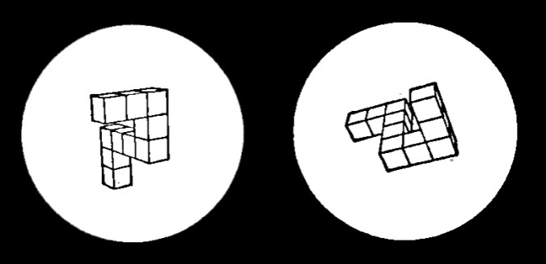
In this study, different game design criteria will be applied to try to make a cognitive task training scenario more exciting and challenging to the learner. The Mental Rotation Task is a standardized assessment of cognitive skills (Shepard and Metzler, 1971). However the game design criteria are chosen based on their general applicability to other cognitive tasks. According to Gilleade (2005), the affective design criteria (see Table 1) can be grouped according to what they aim to influence: Level of challenge, level of assistance, and player mood.

Figure 1 The Mental Rotation Task: are these objects the same?

Table 1 The affective game design criteria evaluated in this study
Challenging | Assisting | Mood enhancing
Adapt game difficulty based on skill level of player | Provide multimodal feedback on task goals and performance | Adapt game difficulty based on inferred affective state of player
Multiple high score tables to show a variety of player achievements | Provide supportive feedback when performance is low, and when performance is high | Use of affective auditory effects to influence mood and emotion
Multiple game modes:  - Normal  - Time limited  - ‘Sudden death’  - Max 3 incorrect answers | Provide peripheral visual cues which offer additional depth cues | Use of in-game music to influence mood and emotion
Add a secondary task to the game | The player can ask for help with a trial for a limited number of times, possibly with a score penalty
Variable payoff mechanisms
Award in-game medals to the player

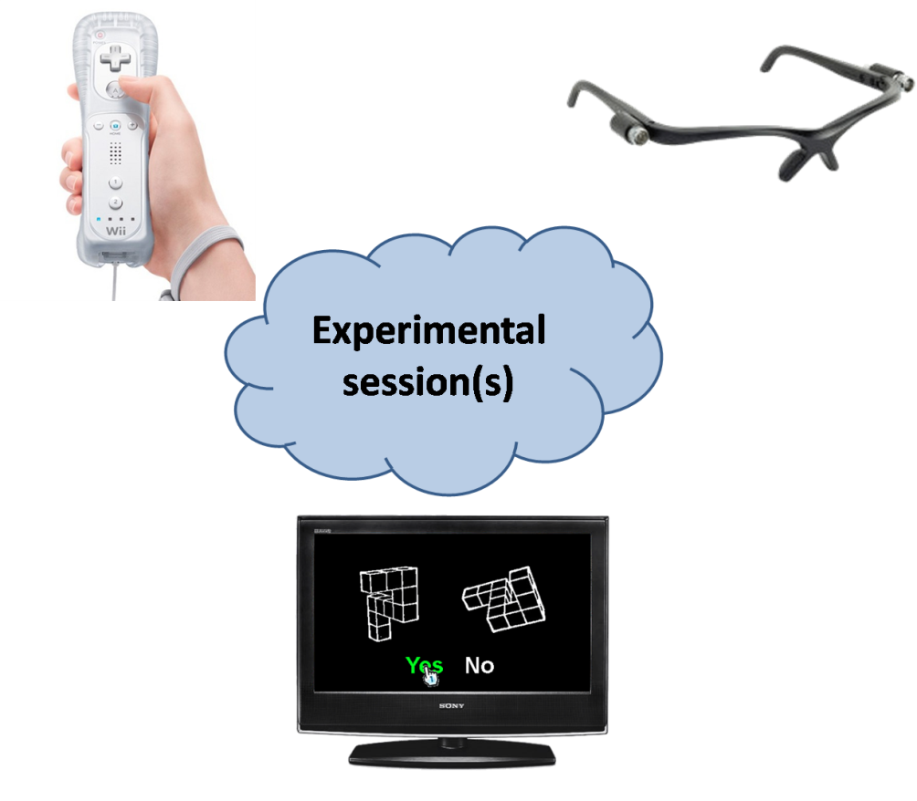
To facilitate this investigation, a proprietary computer based version of the Mental Rotation Task has been created. Figure 2 gives an overview of the computer devices that are used. A TV is used to present the task to the player. The player is standing or sitting in front of the TV and interacts with the system by using a Nintendo Wii remote in his or her hand. This device acts as a pointing and selection device, and also allows auditory and tactile feedback to be presented to the player. The player also interacts with the system by wearing infra red LED eye glasses, which allow the system to track the player’s head position and gaze direction.
Figure 2 An overview of the technology to which participants of this study are directly exposed: the Nintendo Wii remote, infra red LED eye glasses and a flatscreen TV running a computer game based on the mental rotation task.

Research method
A randomized controlled design is applied; The participants are divided randomly into two equally sized groups. Each participant is subjected to one experimental session of 60 minutes (see Table 2). Each session starts with a brief introduction to the content of the session by a responsible researcher. The remainder of the session consists of a questionnaire (asking about the participant background, see section e) on the next page), a task training round using a computer based version of the Mental Rotation Task (MRT), another questionnaire (asking about motivational feedback, see section e) on the next page) and a performance assessment round using a computer based version of the MRT.

Table 2 The experimental protocol used in this study
 | Duration (minutes) | Group 1 (n=26, control) | Group 2 (n=26)
Introduction | 5
Questionnaire 1 | 5
Training round | 22 | MRT: Standard mode | MRT:Affective mode
Questionnaire 2 | 5
Assessment round | 8 | MRT: Standard mode | MRT: Standard mode

During the training and assessment rounds, two computer based versions of the MRT will be used: standard mode and affective mode. These two versions are described as follows:

- Standard mode: this presents the participant with an augmented reality based version of a traditional computer based MRT. In this mode the participant stands in an open area in front of the TV screen, and is wearing the infra red eye glasses and holding the Wii Remote. 30 MRT trials are presented using augmented reality techniques, causing them to appear to the participant as interactive holographic illusions in front of the TV. Using augmented reality offers the participant an additional visual cue (motion parallax) over a traditional computer based version. The participant responds to each trial by using a handheld pointing and selection device to acquire and select one of two virtual buttons on the TV screen. Each session records performance data (response time and response correctness) on 30 trials.

- Affective mode: this mode is based on the standard mode, but presents the participant with a game that has been designed to engage and motivate the participant, as well as to have therapeutic effects. Each session records performance data (response time and response correctness) on all trials.

Prior to the start of the training and assessment rounds, the participants are presented with three practice stimuli which allow them to get used to the task and its supporting human computer interaction devices.

Time frame
Participant acquisition will start after obtaining approval from the Ethics Committee, and will last for one month. As an example the participant acquisition could be conducted from March 22nd 2010 to April 26th 2010.

The experiment itself will be conducted after the participant acquisition has been completed. Assuming that three sessions can take place on a single day, the experiment will run for about one month. As an example this could be from May 3rd 2010 to Jun 7th 2010.

Questionnaires/surveys
Interacting with computers (for the first time) can be a tiring experience to the elderly population. Therefore it has been decided to keep the amount of questions as limited as possible. For the same reason all the questions used require the participant to select one or more answers, or to mark his answer on a Likert scale. Please refer to Appendix 7 for an overview of the questions asked in the questionnaires. In the first questionnaire, 11 answers are provided by marking appropriate checkboxes, and in the second questionnaire the 25 answers are marked on a 5 point Likert scale.

Appendix 3: Expected risks and according precautionary measures
This section details the few risks involved with the technical setup used in the experiment. The setup as detailed in Figure 2 requires the participant to physically move in an open area in front of a TV. This area should be made free of all physical objects which could cause the patient to fall and injure themselves. To prevent postural instabilities from participants during the experiment, they are allowed to take breaks between the different phases of a session or during the training phase (see ). Alternatively the participants can complete the session while sitting down on a chair in front of the TV, instead of standing up. The responsible researcher present at the experiment can remind the participant that he or she can take a small break if necessary. To minimize this risk the participant can be asked to sit down on a couch or chair that is placed in front of the TV, while still being able to interact with the virtual environment by moving his or her head and upper body.
Since the used human computer interaction devices recognize gestures made by the arm that holds the device, a risk is that the participants hit their arms into physical objects while performing the gestures. As stated before, to limit the chance of personal injury all physical objects must be removed from the area in front of the TV. Furthermore the interaction with the game is designed in such a way that it does not require the participant to (wildly) wave their arms around, but is limited to pointing, selecting and dragging of virtual objects on the screen.
During a typical experimental session the responsible is in the same room as the participant. Once the session is started the responsible researcher acts as a passive observer. The responsible researcher and the student observer are not exposed to any risks for physical injury.

Appendix 4: Principle investigator

Curriculum vitae of principle investigator Prof. Dr. –Ing. Robert Riener:

Since June 2006 Associate Professor for Sensory-Motor Systems at ETH Zurich (Department of Mechanical Engineering and Process Engineering) and University of Zurich (University Hospital Balgrist, Medical Faculty).
August 2005 Call to a full professorship on Biomechanics and Movement Science, University of Karlsruhe: declined
May 2003 – May 2006 Assistant Professor for Rehabilitation Engineering at ETH Zurich (Dept. Information Technology and Electrical Engineering) and University Zurich (University Hospital Balgrist, Medical Faculty).
Guest Lecturer at TU Munich, Germany, and University Koblenz-Landau, Germany
January 2003 Habilitation in “Biomechatronics” at the Faculty of Electrical Engineering and Information Technology, Technical University (TU) Munich.
Thesis title: “Technology of Multimodal Virtual Reality in Medicine”.
March 2002 Offer of an assistant professorship at Iowa State University (Dept. of Health and Human Performance): declined
March 1999 – April 2003 Research Associate at the Institute of Automatic Control Engineering (Prof. G. Schmidt) and coordinator of the Biomedical Engineering Group, TU Munich
Jan. 1998 – Feb. 1999 Postdoctoral work at the Centro di Bioingegneria (Prof. A. Pedotti), Politecnico di Milano
May 1997 Dissertation at the TU Munich.
Thesis title: „Neurophysiological and biomechanical modelling for the development of neuroprostheses“ ("summa cum laudae")
July 1993 – Dec. 1997 Research Assistant at the Institute of Automatic Control Engineering (Prof. G. Schmidt), TU Munich, Germany
Sept. 1992 – April 1993 Diploma thesis at the University of Maryland, USA
Scholarship: Prof. Erich Müller Stiftung
Nov. 1988 – April 1993 Study of Mechanical Engineering, TU Munich, Germany, Major: Aerospace

Publication list of principle investigator (of the past 5 years)

Staubli, P., Nef, T., Klamroth, V., Riener, R. (2009) Effects of intensive arm training with the rehabilitation robot ARMin II in chronic stroke: Four single-cases. Journal of NeuroEngineering and Rehabilitation. Submitted
Nef, T., Kiefer, G., Mueller, R., Riener, R. (2009) Effects of arm training with the robotic device ARMin I in chronic stroke: Three single cases, Neurodegenerative Diseases, in press.
Wellner, M., Sigrist, R., von Zitzewitz, J., Wolf, P., Riener,R. (2009) Does Virtual Audience Influence Rowing? Journal of Sports Engineering and Technology. In press
Nef, T., Guidali, M., Riener, R. (2009) ARMin III – Arm therapy exoskeleton with ergonomic shoulder actuation, Applied Journal of Bionics and Biomechanics, in press.
Riener, R., Leypold, K., Brunschweiler, A., Schaub, A.F., Bleul, U., Wolf, P. (2009) Quantification of friction force reduction induced by obstetric gels. Medical & Biological Engineering & Computing, 47, pp. 617-623.
Banz, R., Bolliger, M., Müller, S., Santelli, C., Riener, R. (2009) A method of estimating the degree of active participation during stepping in a driven gait orthosis based on actuator force profile matching. IEEE Transactions on Neural Systems and Rehabilitation Engineering, 17, pp. 15-22.
Zitzewitz, J., Wolf, P., Novakovic, V., Wellner, M., Rauter, G., Brunschweiler, A., Riener, R. (2008) A real-time rowing simulator with multi-modal feedback. Sports Technology. 1, pp. 257-266.
Wellner, M., Schaufelberger, A., Zitzewitz, J., Riener, R. (2008) Evaluation of Visual and Auditory Feedback in Virtual Obstacle Walking. Presence: Teleoperators and Virtual Environments, Vol. 17, pp. 512-524.
Yu, N., Hollnagel, C., Blickenstorfer, A., Kollias, S., Riener, R. (2008) Hydraulics and pneumatics for MRI-compatible actuation. IEEE Transactions on Mechatronics. 13, pp.268-277.
Panchaphongsaphak, B., Riener, R., Ulmer, B. (2008) Contact-sensitive artefacts: tangible interfaces from force-torque sensing approach. International Journal of Arts and Technology (IJART), in press
Fuhr, T., Quintern, Q., Riener, R., Schmidt, G. (2008) Assisting locomotion in patients with paraplegia. Control of WALK! – a cooperative patient driven neuroprosthetic system. IEEE EMBS Magazine 27, pp. 38-48.
Korb., W., Burgert, O., Schulze-Kissing, D., Riener, R. (2007) Kooperative Mensch-Maschine Systeme in der Chirurgie und Rehabilitation. Automatisierungstechnik at, 55, 511-520.
Nef. T.,Mihelj, M., Riener, R. (2007) Arm therapy robot ARMin. Medical & Biological Engineering & Computing, 45, pp. 887-900.
Lünenburger, L., Colombo, G., Riener, R. (2007) Biofeedback for robotic gait rehabilitation. Journal of NeuroEngineering and Rehabilitation 4:1.
Panchaphongsaphak, B., Burgkart, R., Riener, R. (2007) Three-dimensional touch interface for medical education. IEEE Transactions on Information Technology in Biomedicine 11, pp. 251-263.
Mihelj, M., Nef, T., Riener, R. (2006) A novel paradigm for patient cooperative control of upper limb rehabilitation robots, Advanced Robotics 8, pp. 843-867.
Frey, M. Colombo, G., Vaglio, M., Bucher, R., Jörg, M., Riener, R. (2006) A novel mechatronic body weight support system. IEEE Transactions on Neural Systems and Rehabilitation Engineering 14, pp. 311-321.
Frey, M., Hoogen, J., Burgkart, R., Riener, R. (2006) 9 DOF Haptic Display of the Munich Knee Joint Simulator. Presence-Teleoperators and Virtual Environments 15, pp. 570-587.
Frey, M, Riener, R., Michas, C., Regenfelder, F., Burgkart, R. (2006) Elastic properties of the intact and ACL ruptured knee joint: measurement, mathematical modelling, and haptic rendering. Journal of Biomechanics 39, pp. 1371-1382.
Nef, T., Colombo, G., Riener, R. (2005) ARMin – Roboter für die Bewegungstherapie der oberen Extremitäten. Automatisierungstechnik at 12, p. 597-606.
Riener, R., Lünenburger, L., Jezernik, S., Anderschitz, M., Colombo, G., Dietz, V. (2005) Cooperative subject-centered strategies for robot-aided treadmill training: first experimental results. IEEE Transactions on Neural Systems and Rehabilitation Engineering 13, p. 380-393.

Appendix 5: Participants

Exact number of participants

With the results collected during the assessment phase of the experimental session (see Table 2) the quantitative effects of the type of task training (Normal vs. Affective) on task performance can be measured. The number of participants required to measure an expected large effect size is 52 (Based on an independent two-sample t-test, with power = .80, alpha=.05)

The results collected during the 2nd questionnaire phase of the experimental session (see Table 2) provide qualitative feedback on game design criteria which are perceived as engaging and motivating.

Selection and exclusion criteria
Participants are selected for inclusion (by the project collaborators) if they meet the following criteria:

- Age: 45-70.
- Must be able to stand and/or walk for about 20 minutes, allowing one or two breaks of 2-3 minutes.
- No history of motion sickness.
- No physical disabilities.
- No medical condition.
- Little to no computer gaming history.
- No medicine usage that would alter cognitive capabilities (e.g. learning, perception, memory, visuo-spatial abilities).
- Vision corrected to standard.
- Basic understanding of spoken and written English.

Recruitment of participants

Participants will be recruited by project collaborators both internally at, and externally from the ETH. Internal recruitment is initiated by word of mouth and email communication. External volunteers will be recruited through an advertisement campaign through the office of Corporate Communications at the ETH.

Appendix 6: Information sheet for participants
Cp. following pages

Appendix 7: Consent form
Cp. following pages

_________________
November 29, 2009 / GA

Appendix 6: Information sheet for participants
Study title: Investigating the effects of affective game design on player motivation and task performance

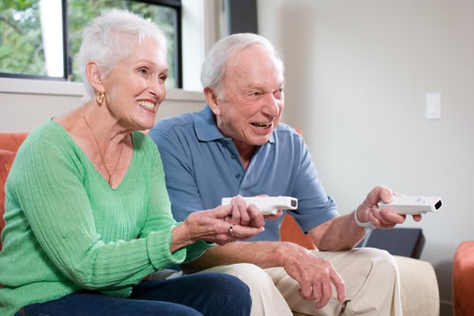
Goal of the study
This study aims to investigate how computer game based training can be designed, so that it increases the motivation to engage with the training as well as the practicability of the used interaction devices. This knowledge may ultimately help to design computer based training scenarios which prevent a loss of mental skills due to the normal aging process in healthy elderly people, or due to symptoms such as Alzheimer’s Disease.

Research procedure
We invite a number of volunteers like you to come to our lab for less than one hour. During that time you will first be asked to complete a questionnaire which asks you about your background information. This will take about 5 minutes. Thereafter you will be required to play a computer game which trains you to perform a basic task. In this computer game you are presented with two objects on a TV screen, after which you must decide if these objects are the same or not. This task training will last for about 22 minutes. Thereafter, we ask you to fill out a questionnaire regarding the experiences you had during your training with the computer game. This will take about 5 minutes. Finally, you are expected to once again play the computer game for about 8 minutes, during which your performance is recorded. Based on your answers and your performance data we expect to define design criteria of enjoyable therapeutic computer games.

Schedule
You will be invited to come to our lab and participate in the study in the period from May 3rd to June 7^{th.}

Conditions to be met for participation in the study
- Your age must be between 45 and 70.
- You must be able bodied and capable of independent living.
- Your need to have an average to good mental health for people from your age, and not suffer from any severe impairment.
- You must have no history of postural instabilities, so you can stand in front of a TV to play a computer game.
- You must have no history of motion sickness, such as car sickness.
- You must not be using any medicine that would alter your mental capabilities. If you are using medicine, please consult with your Doctor to find out if you can still be admitted.
- Your vision must be standard, or corrected to standard by wearing glasses or contact lenses.

Advantages and disadvantages for participants / Risks
There are very few risks for your personal health involved with your participation. We will take precautions to make sure that you cannot injure yourself while standing in front of a TV and playing the game. If your physical fitness limits you from standing in front of a TV, you can also sit down to prevent you from falling and hurting yourself.
Participating in this experiment has some advantages for you. You have the opportunity to help scientists and engineers to improve existing computer based training methods for mental skills. In the future this knowledge may help to improve the effectiveness of treatment methods for for instance Alzheimer’s Disease.

Source of funding
This project will be conducted using resources already available at the ETH SMS Lab, with financial support from the IDEA league, a focused network of leading European universities of science and technology.

Compensation/Reimbursement
As a compensation for your time and efforts, we will offer you CHF 50,- per hour of volunteered time.

Right of withdrawal
As a participant, you have the right to withdraw from the study at any time without needing to specify any reasons nor facing negative consequences.

Data protection
The obtained data will be stored safely and reported in an anonymous form. Only the responsible investigators and/or the members of the ethical committee have access to the original data under strict confidentiality.

Insurance coverage
Possible damages to your health, which are directly related to the study and are demonstrably the fault of ETH Zurich, are covered by the general liability insurance of ETH Zurich (insurance policy no. 100.001 of the Swiss Mobiliar insurance company). However, beyond the before mentioned, the health insurance and the accident insurance (e.g. for the way to or back from the study location) is in the responsibility of the participant.

Contact person(s)
B.Buss  0446325917  Bernhard.Buss@mavt.ethz.ch  TAN E 6.2, Tannenstrasse 1  Zurich | Prof. Dr. Ing. Robert Riener  0446326679  riener@mavt.ethz.ch  TAN E 6.2, Tannenstrasse 1  Zurich

Appendix 7: Consent Form

Please read this form carefully.
Please ask the investigator or the contact person if you have any questions.

Study title: Investigating the effects of affective game design on player motivation and task performance

Study location: M3 Lab, Meeting room
ML.F.55
Sonneggstrasse 3
8092 Zürich

Principal Investigator’s Name and First Name: Prof. Dr. –Ing. Robert Riener

Participant’s Name and First Name: ………………………………………………………………………………

Participant:
I participate in this study on a voluntary basis and can withdraw from the study at any time without giving reasons and without any negative consequences.
I have been informed orally and in writing about the aims and the procedures of the study, the advantages and disadvantages as well as potential risks.
I have read the written information for the volunteers. My questions related to the study participation have been answered satisfactorily. I have been given a copy of the information for the volunteers and the consent form.
I was given sufficient time to make a decision about participating in the study.
With my signature I certify that I fulfill the requirements for the study participation mentioned in the information for the volunteers.
I have been informed that possible damages to my health which are directly related to the study and are demonstrably the fault of ETH Zurich, are covered by the general liability insurance of ETH Zurich (insurance policy no. 100.001 of the Swiss Mobiliar insurance company). However, beyond the before mentioned, my health- and/or accident insurance (e.g. for the way to or back from the study location) will apply.
I agree that the responsible investigators and/or the members of the ethical committee have access to the original data under strict confidentiality.
I am aware that during the study I have to comply with the requirements and limitations described in the information for the volunteers. In my own health interest the investigators can, without mutual consent, exclude me from the study.

I will inform the investigators about my medical treatments and medication (prescribed by medical doctors or self-purchased).

If in the course of the study, a clinical finding occurs which could lead to diagnosis, treatment or prevention of existing or future diseases:
I want to be informed.
I do not want to be informed.

Location, date . . . . . . . . . . . . . . . . . . . . . . . . Signature volunteer . . . . . . . . . . . . . . . . . .

Location, date . . . . . . . . . . . . . . . . . . . . . . . . Signature investigator . . . . . . . . . . . . . . .

Appendix 7: Questionnaires to be completed during a session

Questionnaire 1: participant background

Question | Possible answers
- What is your gender | Male  Female
- What is your highest educational attainment? | University  Undergraduate  College  Other  I did not receive any formal education
- What kind of equipment do you use regularly? Please mark all that apply | TV  Radio  Telephone  Mobile phone  Digital photo camera  Personal Computer  Video game console
- What kind of games do you like to play? | Strategy games (bridge, chess)  Skill games (Mikado)  Knowledge games (triviant, scrabble)  Thinking games (Sudoku, crossword puzzles)  Other  I don’t play games
- Would you like to play such games on the computer ? | Yes  No
- Would you like to play games on the computer by yourself? | Yes  No
- Would you like playing games on the computer, with or against people who are located elsewhere? | Yes  No
- How often do you use a computer? | About once a week  A few times a week  Every day  I don’t use a computer
- What do you use a computer for, if any? | Looking up information (eg recipes)on websites  Playing games  Typing and printing letters  Sending and reading email  Managing and printing my photos  Chatting  Other
- Would you be interested in playing computer games which train your mental skills? | Yes  No
- What do you expect from computer games which train your mental skills (mark any that apply) | They should be fun  They should be challenging  They should be easy in difficulty  They should be hard in difficulty  They should be easy to understand  They should be easy to use  They should be playable with others (cooperative)  They should be playable with others (competitive)  They should be playable alone  They should allow me to engage in social activities

Questionnaire 2: participant experience

The following 5 point Likert scale is used for all questions, unless indicated otherwise.

1 | 2 | 3 | 4 | 5
Strongly disagree |  | Neither disagree nor agree |  | Strongly agree

Topic | Questions
General interest/enjoyment /motivation | - I found the training round enjoyable to do
Game design: Adaptive difficulty | - I like it when games are easy for me to play
Game design: High scores | - I would play this game again to improve my high score(s)
Game design: Game modes | - Being able to play the game in different modes makes me want to play it again
Game design: Medals | - I like that there are different medals to be earned by playing the game
Game design: Secondary task | - I like that there are secondary tasks to be completed in the game
Game design: Supportive feedback | - I like the supportive feedback provided by the game
Game design: Check incorrect answer | - I like it that the game allows me to check incorrect answers
Game design: Use of sound effects | - I like the use of sound effects
Game design: Use of music | - I like the use of music
Performance, learning and motivation | - I think the game was too difficult
Performance, learning and motivation | - I think the controls were easy to learn
Performance, learning and motivation | - I am satisfied with my performance
Performance, learning and motivation | - I would be interested in playing more games which aim to improve everyday life
Performance, learning and motivation | - I think that more training would improve my performance

Information sheet for participants - version 2, February 2nd 2010
Consent form version 1, February 2nd 2010
Questionnaire 1 – Participant background - version 3, February 2nd 2010
Questionnaire 2 – Participant experience - version 3, February 2nd 2010

